**4. The Normal Distribution**

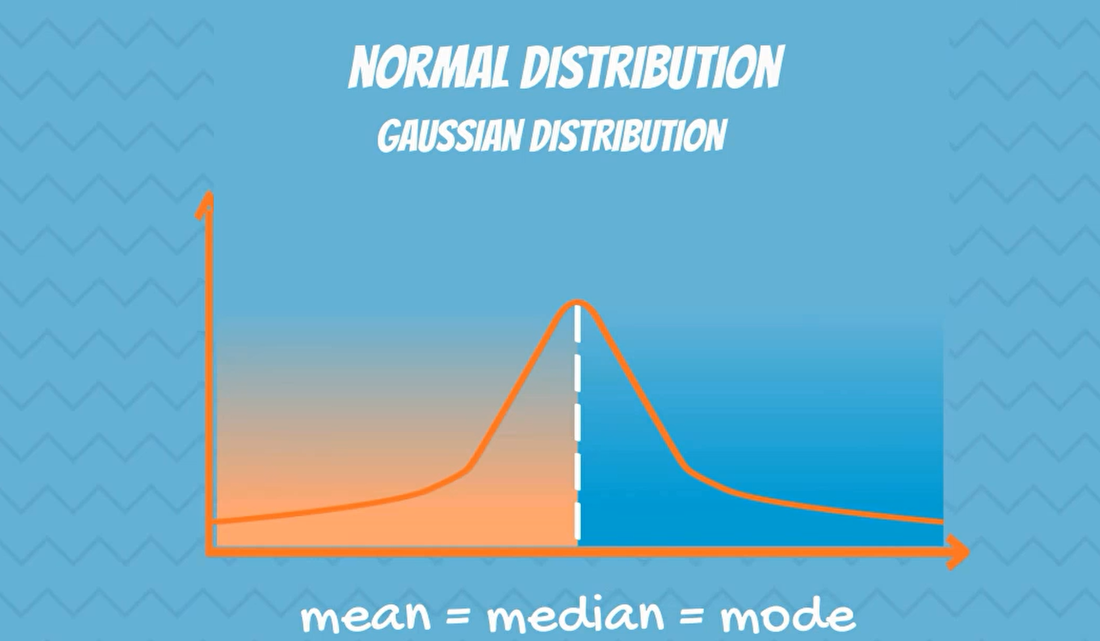

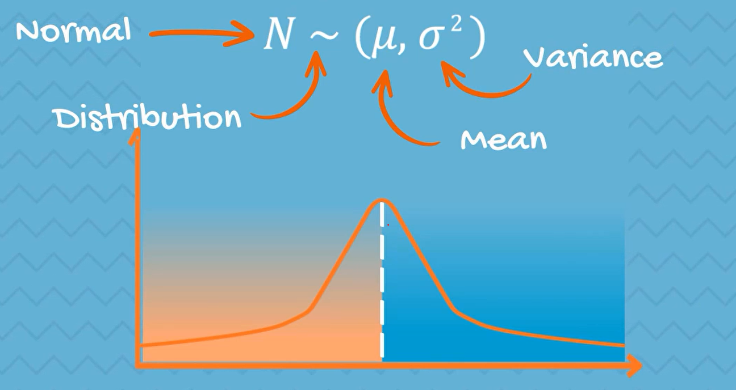

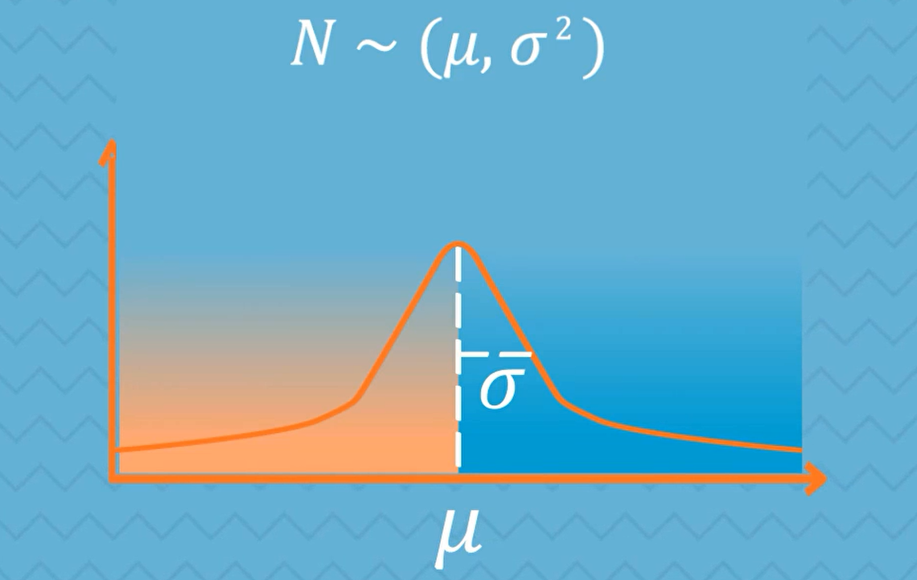

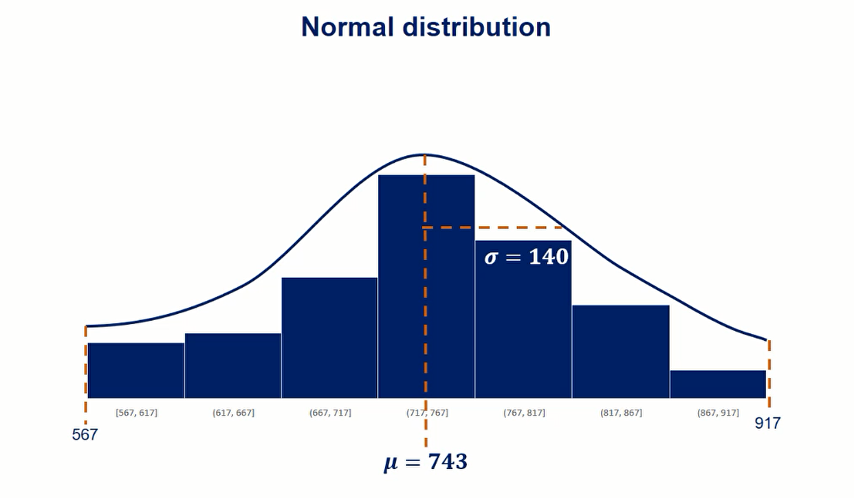

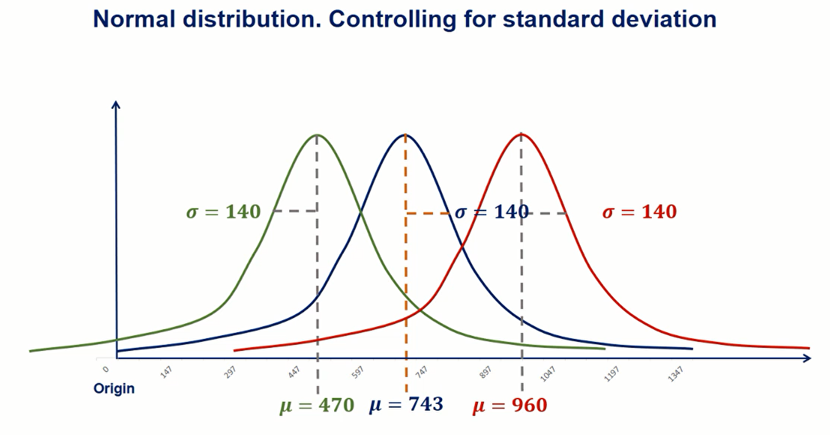



**Controlling for the mean and we can change the standard deviation.**



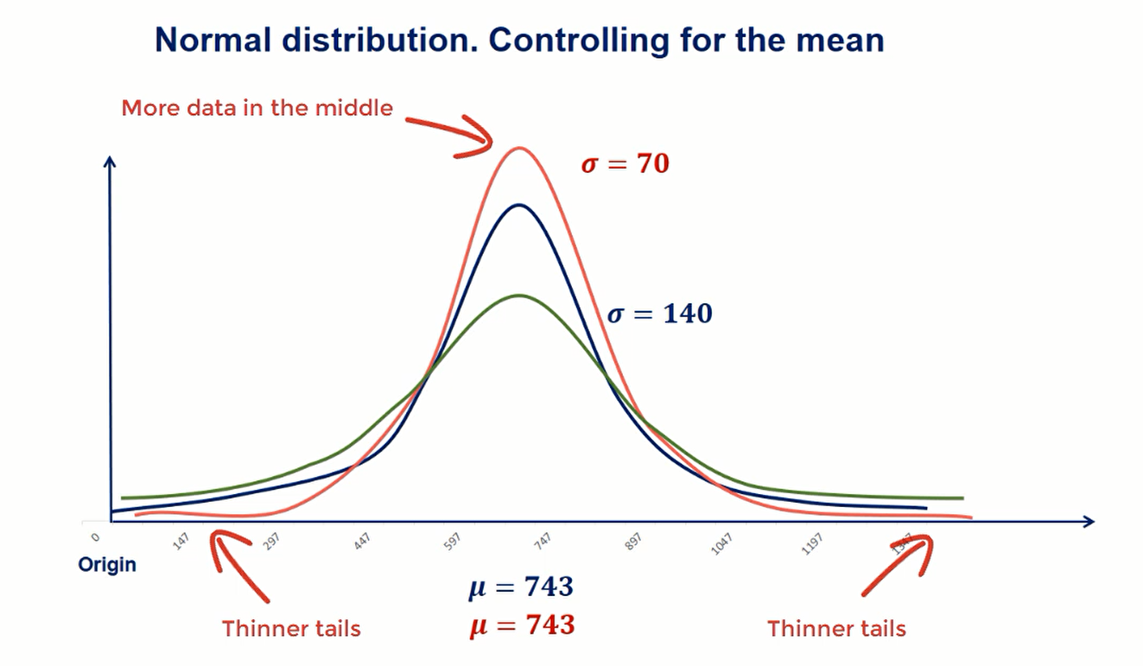

Lower standard deviation result in a lower dispersion, so more data in the middle and thinner tails.

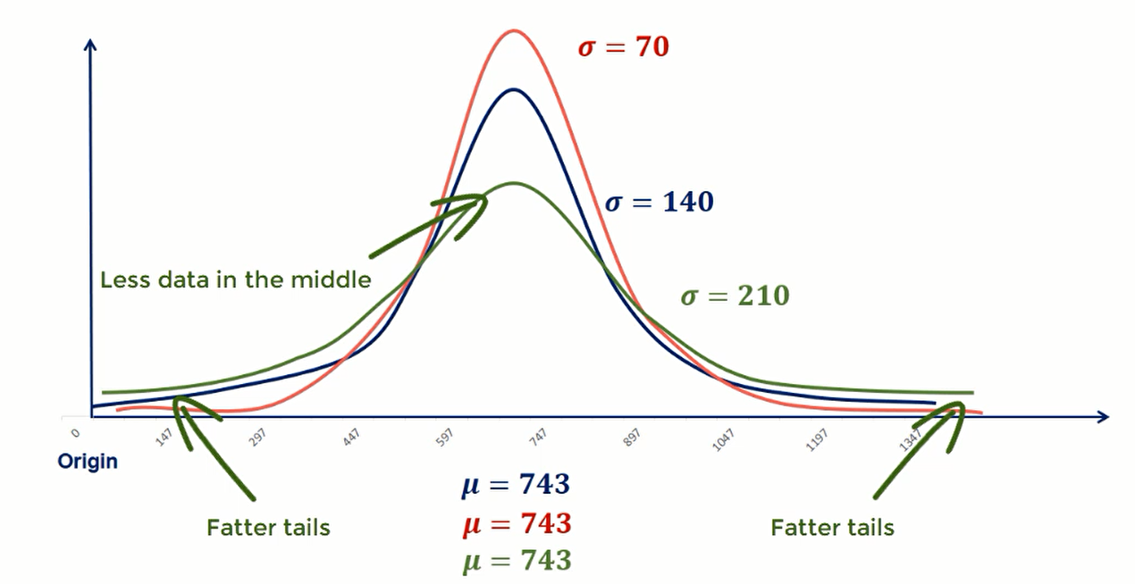

higher standard deviation result in a higher dispersion, so less data in the middle and fatter tails.

**6. The Standard Normal Distribution**

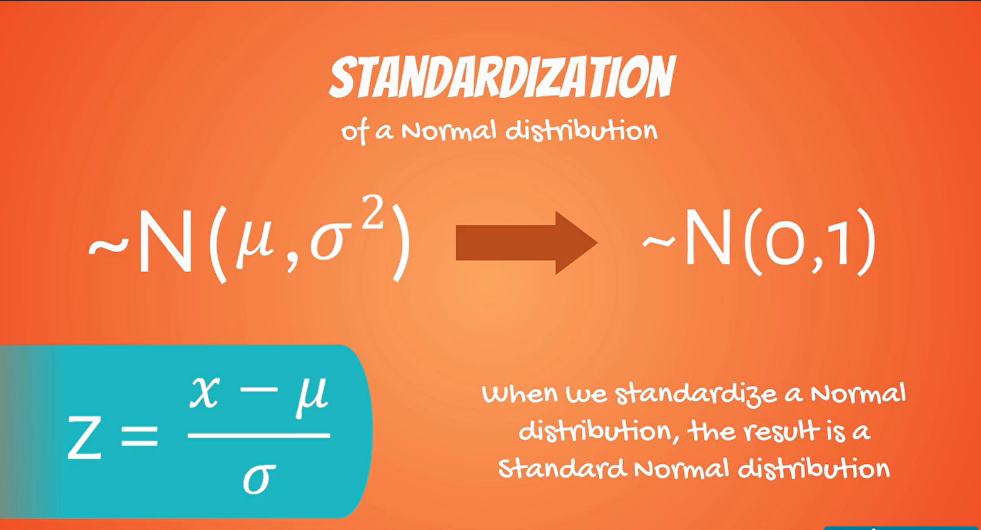

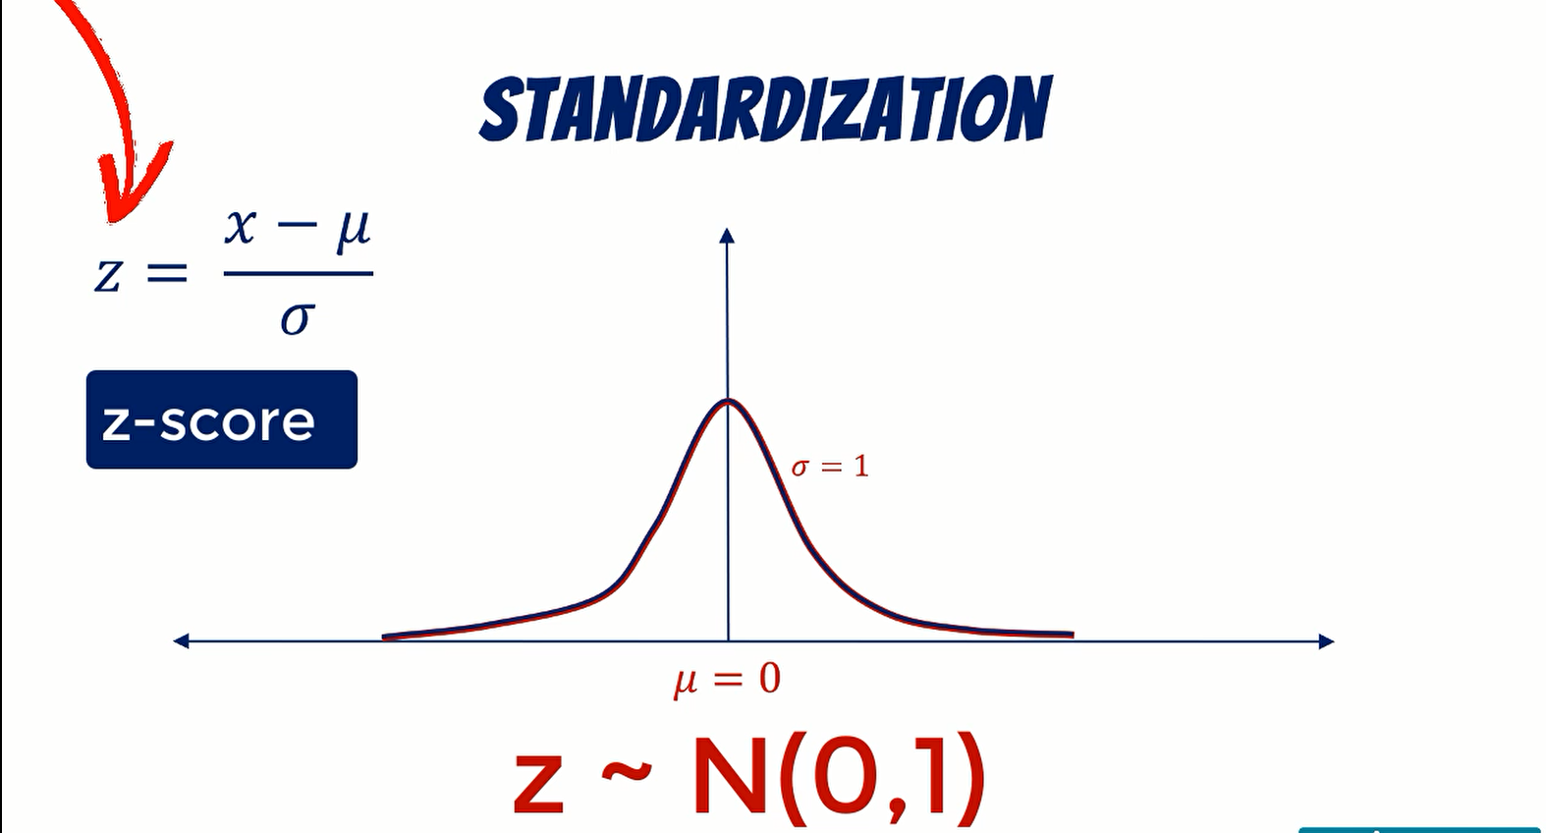

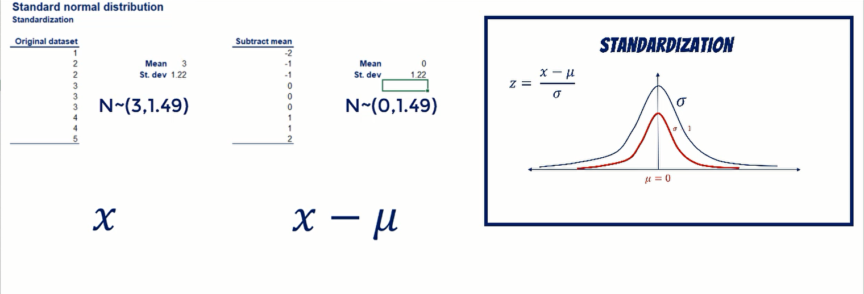

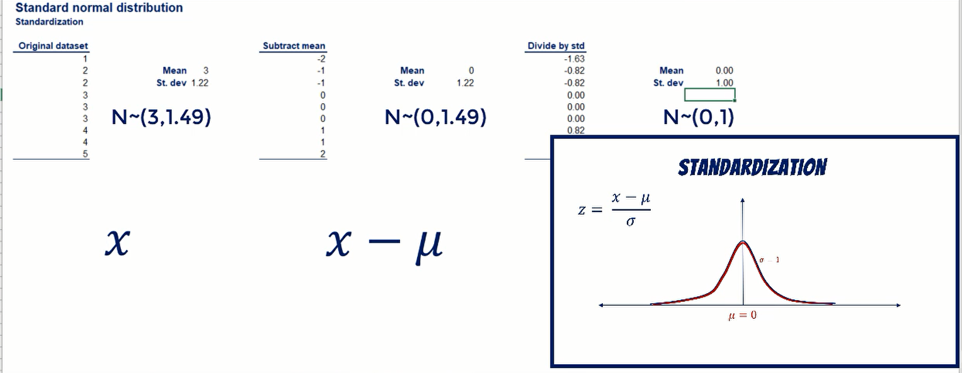

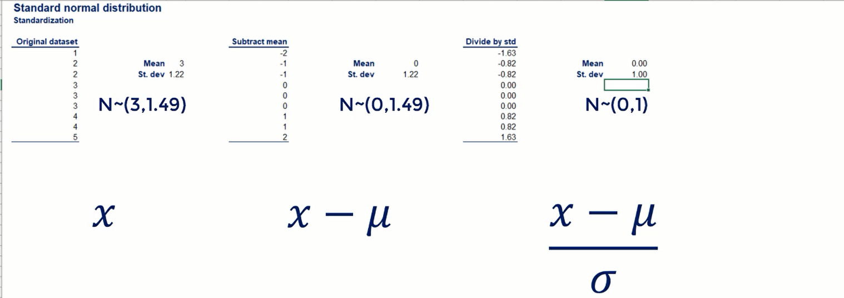

**9.** **Central Limit Theorem**

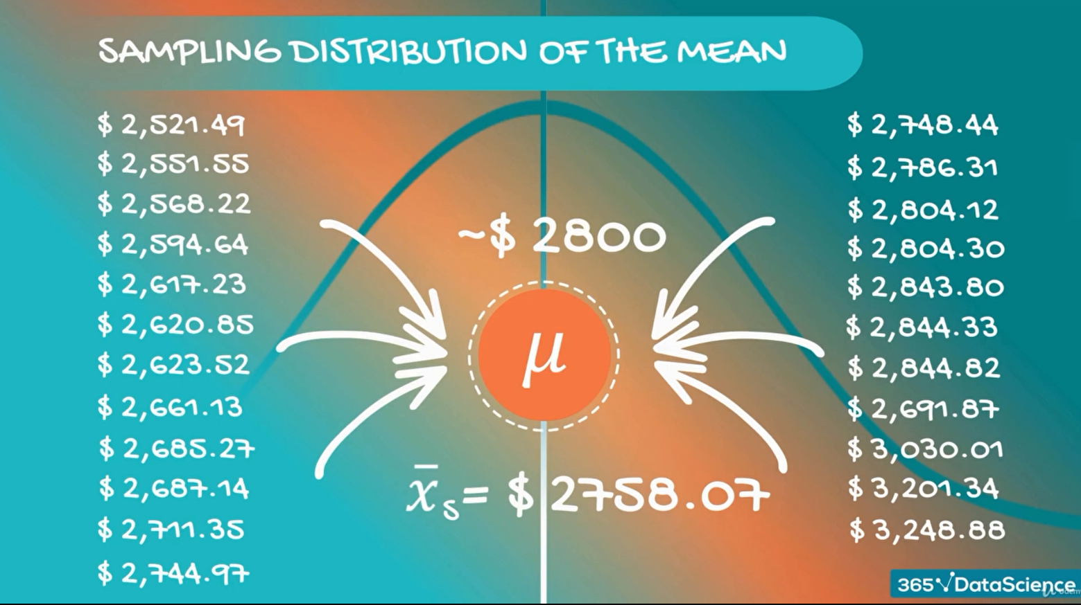

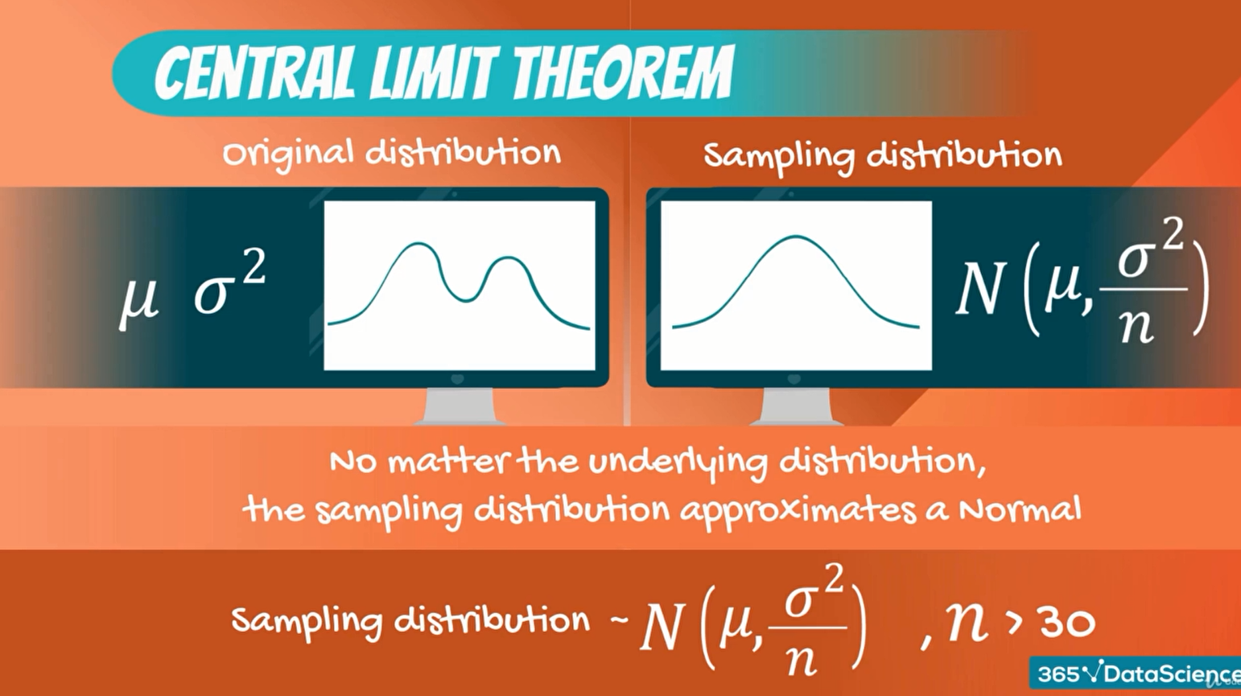

If we are able to draw bigger samples our statistical results will be more accurate usually for Central Limit Theorem apply.

We need a sample size of at least 30 observations.

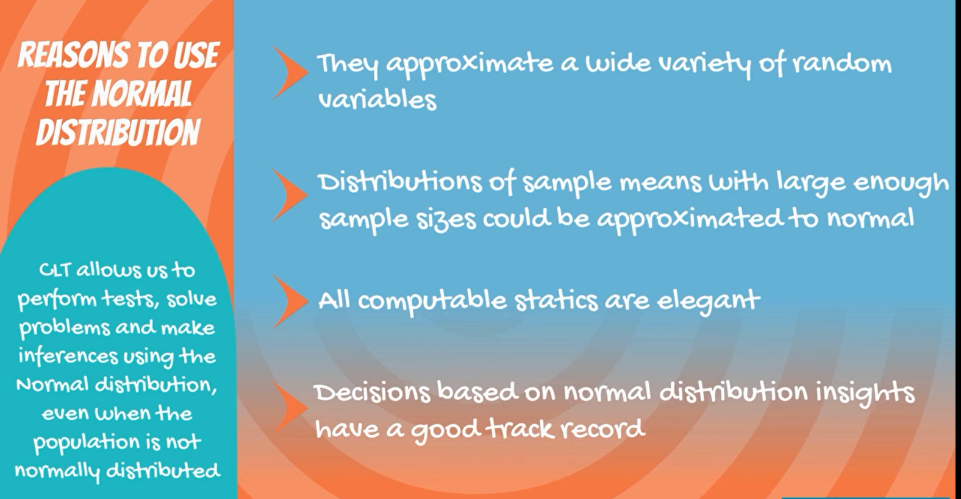

**11. Standard error**

Standard error is the standard deviation of the distribution formed by the sample means.

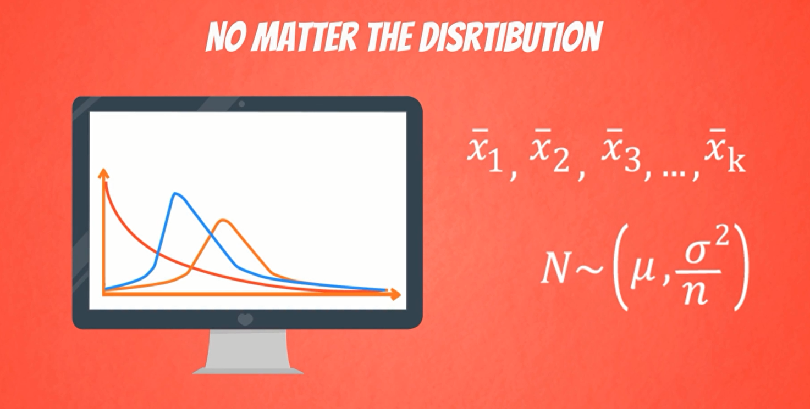

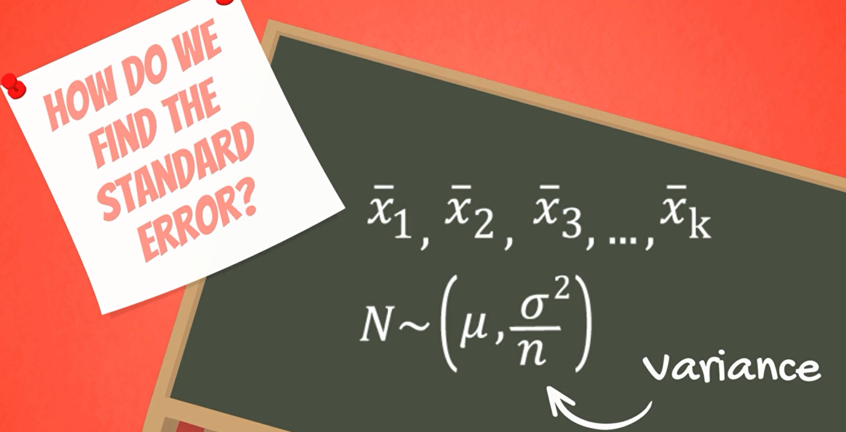

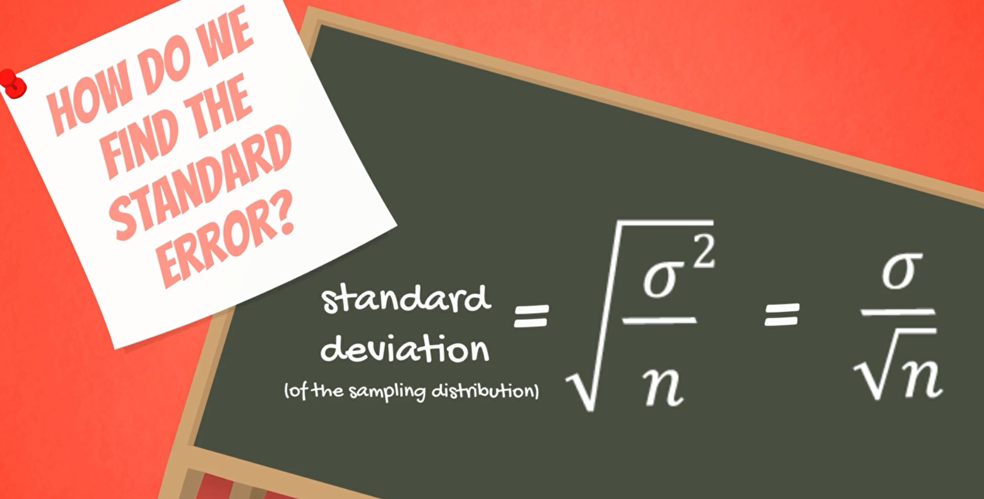

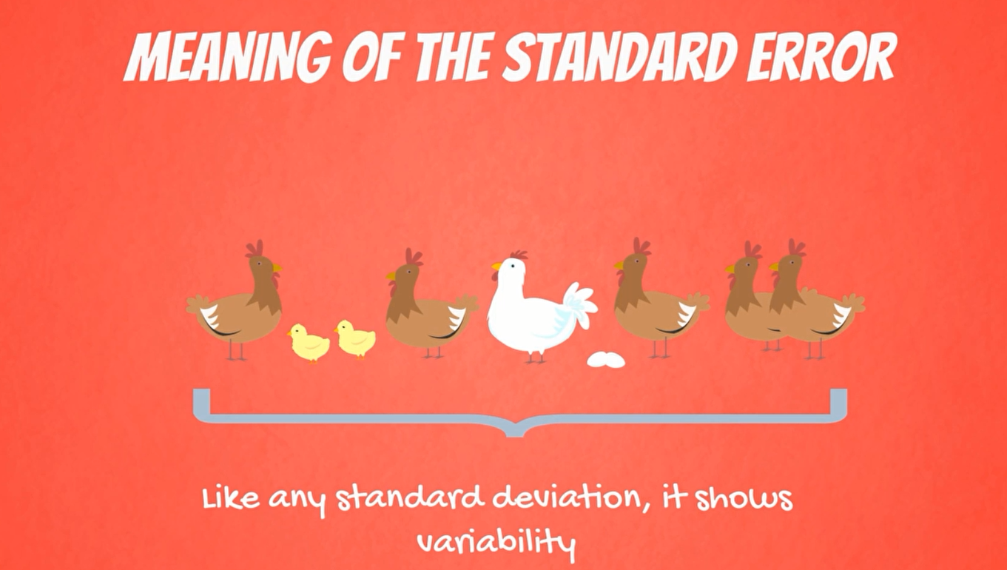

Standard error shows variability

It is the variability of the means of the different samples we extracted

**Note**: Standard error decreases as the sample size increases.

Bigger sample give a better approximation of the population



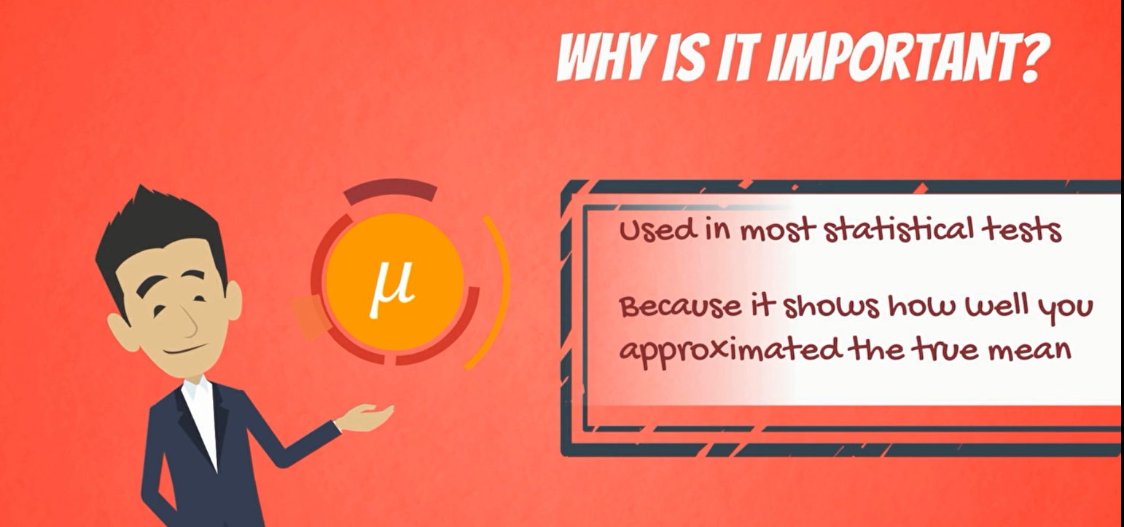

**13. Estimators and Estimates**

Let’s continue by introducing the concept of an estimators of a population parameter.

There are two types of estimates:

1. Point estimates
2. Confidence interval estimates.

A point estimate is a single number

A confidence interval naturally is an interval the two are closely related.

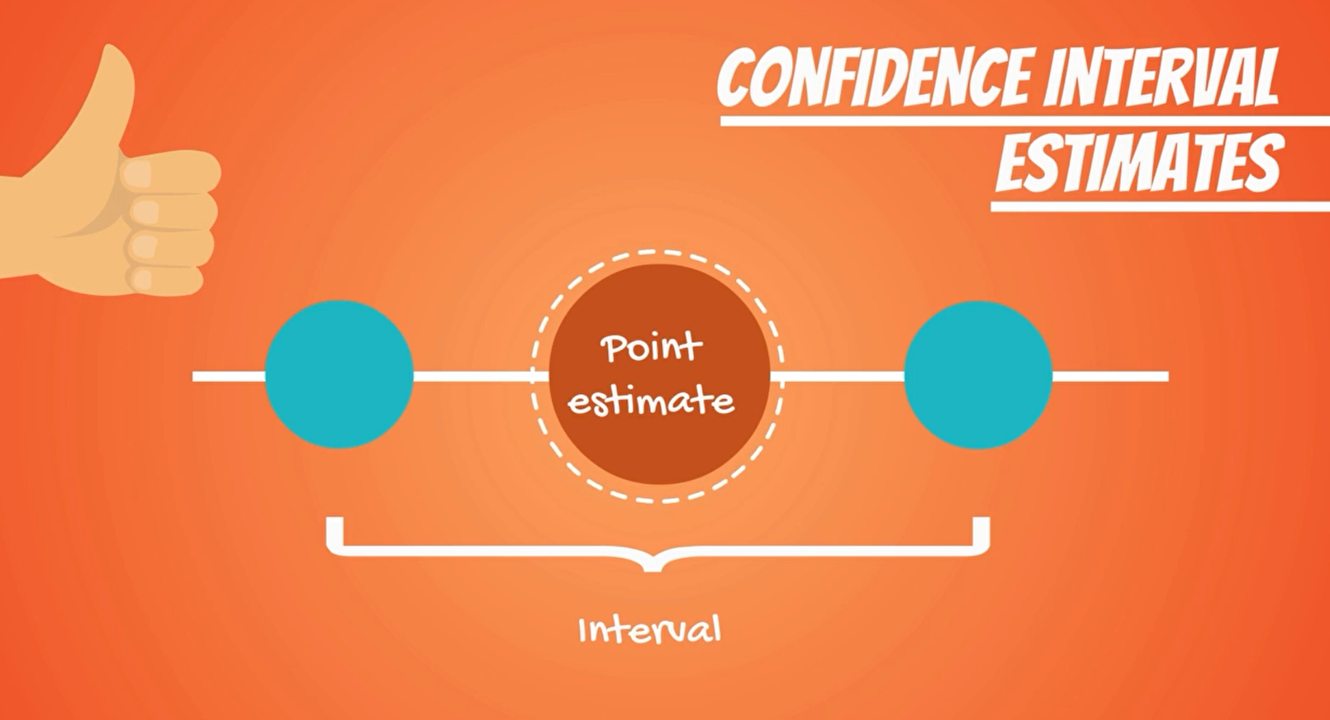

The point estimate is located exactly in the middle of the confidence interval.

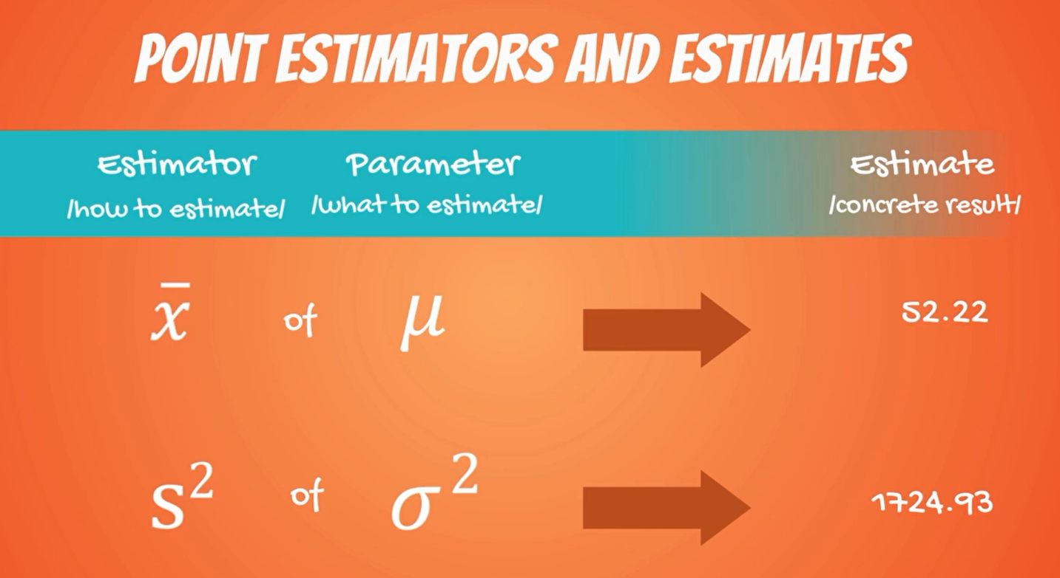

The Sample mean X bar is a point estimate of the population mean mew.

The sample variance S2 was an estimate of the population variance Sigma squared.

They all have two properties:

1. Bias
2. Efficiency

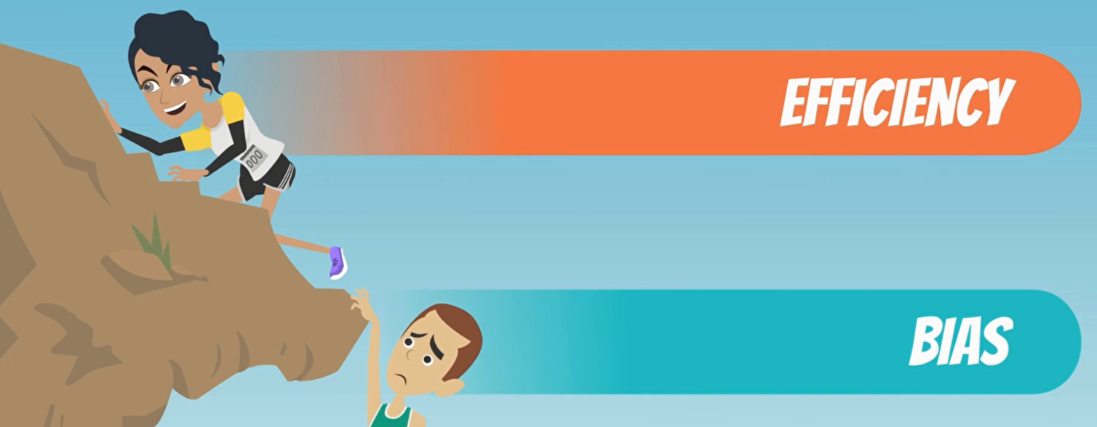

We are looking for the most efficient unbiased estimators and unbiased estimator has an expected value equal to the population parameter.

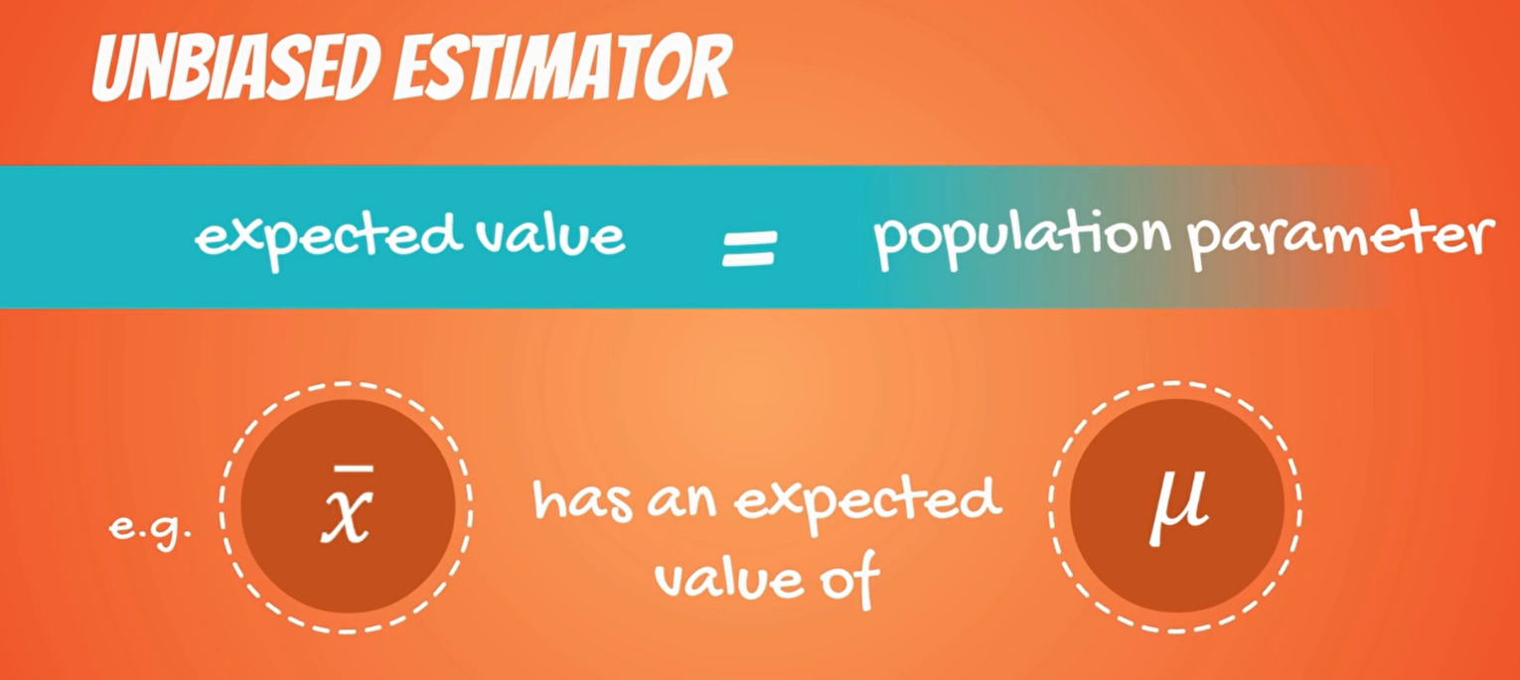

**Bias Estimators**

